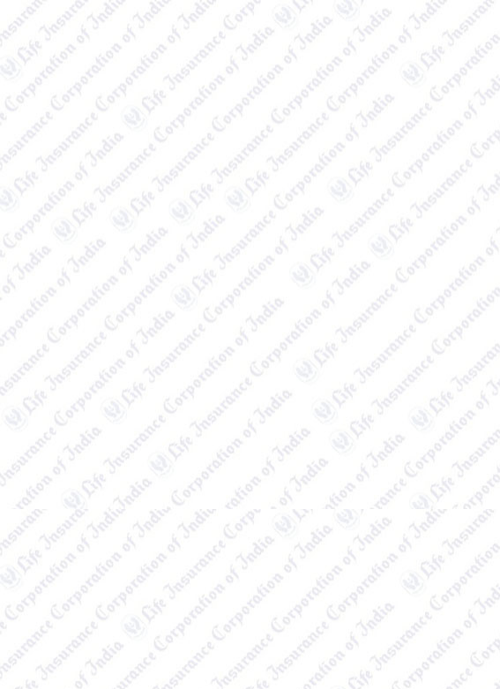

# Collecting Branch : EPS1

**Transaction No :** 2375613

**Date ( Time ):** 15/02/2019 ( 12:46:09 )

**Transaction No. :** PR2375619300011819

# Servicing Branch : 70Z

LIC of India, Chennai City Br Office-30 No-37A Velachery Main Road Velachery

Chennai Chennai

Tamil Nadu 600042

**RENEWAL PREMIUM RECEIPT**

**Received with thanks Rs.** 64459.00 **through Payment Gateway over the Internet from: Smt./Ms./Shri :** Parimi Pradeep

# Towards the following

|  |  |  |  |  |  |  |
| --- | --- | --- | --- | --- | --- | --- |
| **Policy No**  **Name Agency Code** | **Plan**  **Term D.O.C.** | **Inst. Prem(Rs)**  **Mode Sum Assured** | **No Of Inst**  **Due Fr Due To** | **Total Premium**  **Late Fee** | **Service Tax**  **Edu Cess Total Amt** | **Branch**  **Next Due** |
| 706347929 | 179 | 64,459.00 | 1 | 64,459.00 | 0.00 | 70Z |
| Parimi Pradeep  0092970Z | 17  28/09/2012 | YLY 15,00,000.00 | 09/18  09/18 | 0.00 | 0.00  64,459.00 | 09/18 |
| **Page Total (Rs)** | | **64,459.00** |  | **64,459.00** | **0.00** |  |
|  | |  | **0.00** | **0.00** |
|  | |  |  | **64,459.00** |
| **Grand Total (Rs)** | | **64,459.00** |  | **64,459.00** | **0.00** |  |
|  | |  | **0.00** | **0.00** |
|  | |  |  | **64,459.00** |

**GST borne by LIC of India : 1449.46**

RUPEES SIXTY-FOUR THOUSAND FOUR HUNDRED FIFTY-NINE ONLY

Parimi Pradeep

Parimi Pradeep Door No 25-1-1035

Nethaji Nagar 8 Th Street Nellore

524004

Consolidated Stamp Duty Paid

CSD/64/2018/2366/18 dtd. 26/06/2018

Payment Acknowledgement generated through

Online portal on 15-Feb-19 Time : 12:46:09

This receipt is electronically generated and no signature is required.

**Har Pal Aaapke Saath**

**Zindagi Ke Saath Bhi, Zindagi Ke Baad Bhi**

**Page 1of1**